**Course Instructor: Cristina Ruiz Martin**



**Course Project Proposal**

**Advance Topics in Software Engineering: Software Development in C**

**Submitted by:**

Mitulkumar Gajera Sanjana Reddy Sureddy

ID: 101127813 ID: 101167065

Carleton University Carleton University

Git-ID: mitulgajera Git-ID: Sanjanareddy8

**Problem statement**

Automation makes human life easy and with the minimal efforts human can do their work. In smart homes maintaining home/room temperature according to need plays an important role for inhabitants. A home temperature control system maintains room temperature in all seasons. The temperatures can be changed by the user as per the requirements.

When the system turns on, the system will ask user to select the season either winter or summer. Then user will input the measured room temperature and desired room temperature. Here, for sack of simplicity we are giving manual entry to input measured room temperature usually it is automatically measure by the sensors. Once user enters inputs, input validation function will check the validation. When measured room temperature does not match with desired room temperature, according to selected season, system will turn on respected mode. After one cycle that is desired room temperature equals measured room temperature, program will again ask user if he/she wants further to change in temperature. If yes, then program will redirect to user input prompt, if no, then program will stop execution until further user input.

**A. Client Requirements:**

1. Controller requirements:

* The controller should switch between heating and cooling by comparing desired and measured temperatures.
  + If the desired temperature is 280C and Measured temperature is 220C, the system should work as a heating system and when the desired is 280C and measured is 310C, then it should work as a cooling system.
* Controller should be able to save all the user provided inputs.

1. Temperature measurement

* Room temperature (first input by user manually) (after measured by simulation)
* Desired temperature (first input by user manually) (after measured by simulation)

1. User operations

* Turn On/Off system
* Manually Change temperature after every simulation

**B. Assumptions:**

1. User will enter room temperature and the desired temperature at the starting of every simulation.
2. The device will be in standby mode when the house no longer requires change in temperature.
3. Increment in the temperature will be in the integer.

**C. Requirement release:**

1. In first release we will give user inputs, validating inputs, heating algorithm.
   * temperatures between 160C to 350C or not.
2. In second release we will provide cooling algorithm and change in desired temperature functionality.

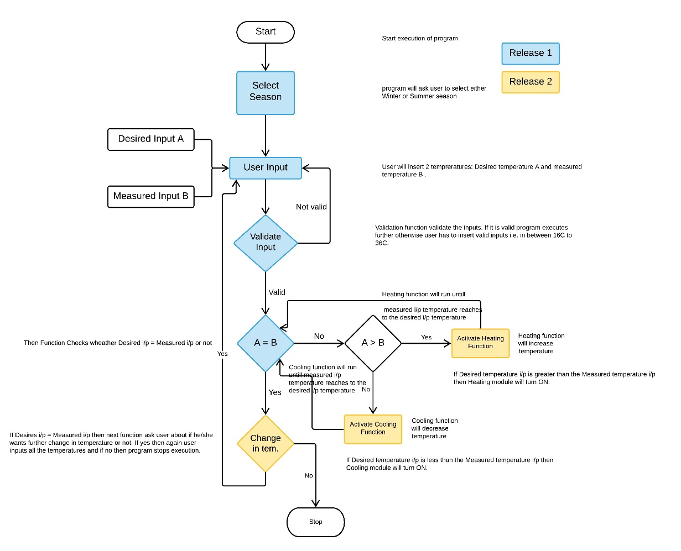**D. Flow Chart:** Functions to be implemented are coloured.

**E. Functions and return value:**

1. **Function Name:** Select Season

**Input parameter:** int season_name1, int season_name2

**Return value:** int

1. **Function Name:** Validate Input

**Input parameter:** intdt = desired temperature, int mt = measured temperature

**Return value:** int

1. **Function Name:** Check Temperature (dt = mt)

**Input parameter:** int dt, int mt

**Return value:** int

[For heating and cooling we introduced new function which is random function. In random function we are passing array value and from which random function will choose one integer value and pass it to the heating function and according to return value from random function temperature will increase/decrease. For example, array [1,2], when random function will call it will choose one value from 1 and 2 and the chosen value will affect the temperature change in heating/cooling function.]

1. **Function Name:** Activate Heating

**Input parameter:** i. random function

i/p of random function: array

return value: integer value from array

ii. int dt, int mt

iii. mt = mt + return value of random function

**Return value:** Updated mt value

1. **Function Name:** Activate Cooling

**Input parameter:** i. random function

i/p of random function: array

return value: integer value from array

ii. int dt, int mt

iii. mt = mt - return value of random function

**Return value:** Updated mt value

1. **Function name:** Change in tem

**Input parameter:** String (Yes/No)

**Return Value:** int

**F. Functions to be implemented by group member:**

* 1. Select Season Sanjana
  2. Input validation Sanjana
  3. Change in temperature Sanjana
  4. Temperature comparison Mitulkumar
  5. Heating function Mitulkumar
  6. Cooling Function Mitulkumar